**Windows Node monitor tutorial (lisk on ubunto)**

**\*\*\*This is work in progree, need a lot of work, but in most cenarios is working***.**

Node monitor is a tool to manage lisk nodes forging uptime, is better to have more than one server per delegate in order to NodeMonitor activate forging server, if mainserver is forked.

NodeMonitor as the concept of mainserver, mainserver is the server that you decide to be your primary node,

After initial configuration of mainserver, NodeMonitor will decide best server to forge.

There can be only one mainserver per delegate.

Note: when NodeMonitor runs and will get informations about all nodes, if main server is ok for forging, it will disable forging on all backup nodes and activate forging on mainserver.

Node monitor uses SSH.net

<https://github.com/sshnet/SSH.NET> to execute commands in lisk Nodes

**Lisk Node Configurations Ubuntu**

1 –NodeMonitor need that Lisk must be installed based on <https://lisk.io/documentation?i=lisk-docs/BinaryInstall>

and assume lisk user and all folders and files are in default locations created by lisk BinaryInstall

2 – Install UFW and enable it, on ubunto and open required ports.

sudo apt-get install ufw

sudo ufw allow 22 ssh port

sudo ufw allow 7000 for testnet

sudo ufw allow 8000 for mainnet

sudo ufw allow 3389 if you use xrdp

sudo ufw enable

sudo ufw reload

3 – white list your windows machine ip where monitor will run, in config json of your node(api, and forging).

"api": {

"access": {

"whiteList": ["127.0.01"] }

},

"forging": {

"secret": [""], -> with monitor running you don’t need secret in config

"access": {

"whiteList": ["127.0.0.1"] }

},

3 – get <http://www.putty.org/> and test your **ssh conection**, from windows machine where node monitor will run

**Open Node Monitor:**

Just open folder “NodeMonitor Executable” and execute NodeMonitor.exe or open visual 2015 solution and compile and run.

**Node Monitor Configurations.**

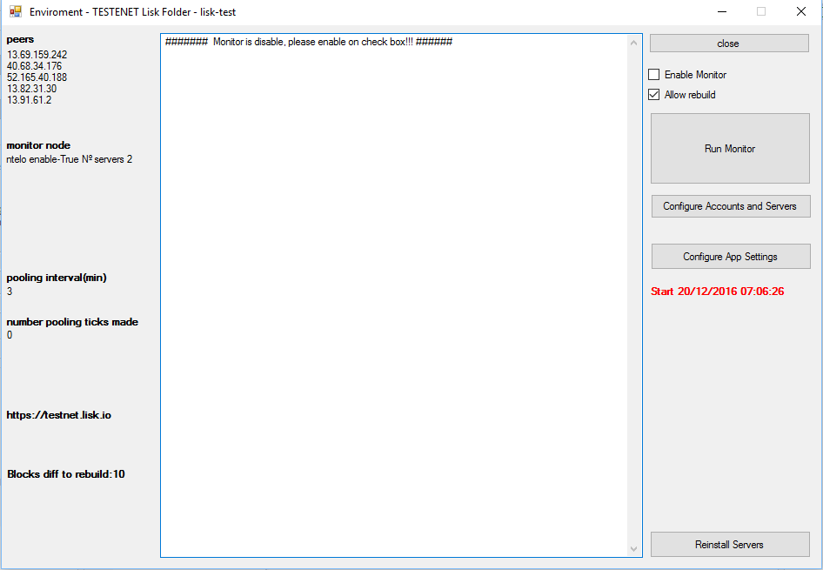

**Configure App Settings**



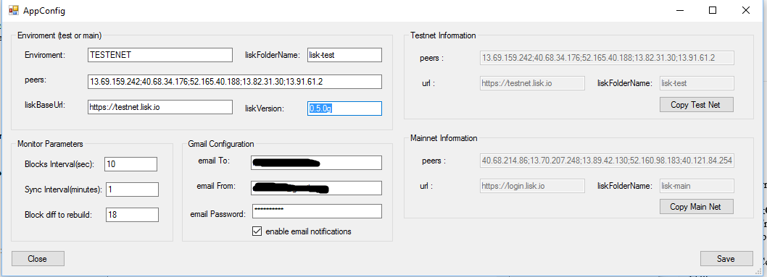

**Configurations:**

**1 - Copy Test Net or Copy MainNet.**

It will copy definitions to left side of screen.

**2 - Lisk Version**

If you use installation with monitor (manual installation it will read version to get the installation files.)

**3 - Monitor Parameters**

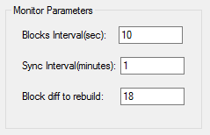

Blocks interval – 10 sec, do not change unless network block time changes.

Sync Interval – monitor will run every x minuts

Block Diff rebuild – if difference from peers is greater than, it will switch monitor and rebuild

**4 – GMAIL configurations**

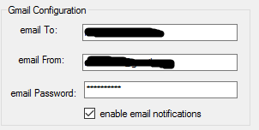

**Email from must be a GMAIL account and you need to enable**

**turn on lesssecureapps in:**

<https://www.google.com/settings/security/lesssecureapps>

**Configure Accounts and Servers**

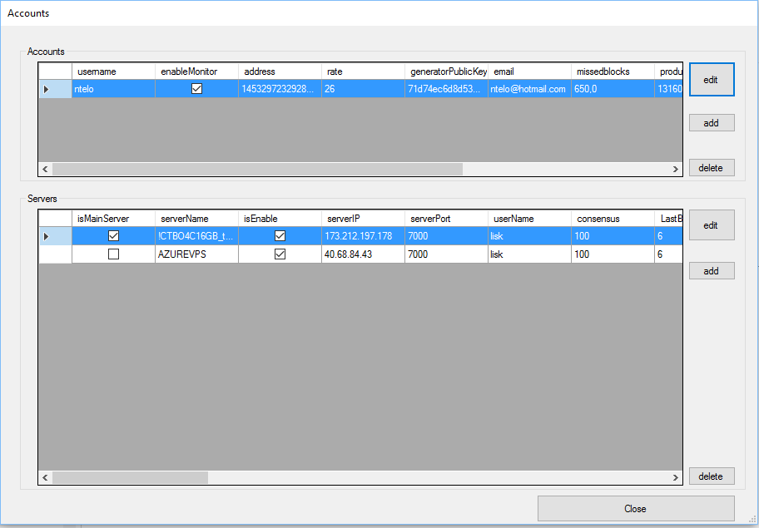

**1 – Add Account**

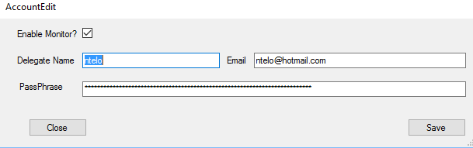

Add Delegate name and 1ª first passphrase and your email.

**2- Add Servers to account**

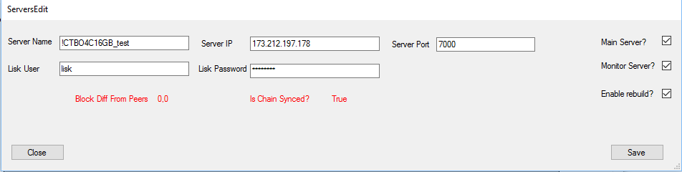

2.1 When you configure servers there can be only one mainserver.

2.2 DO not remove server if in that moment he is mainserver, if you want to change mainserver, change disable mainserver, and enable another one, and run monitor. Monitor will switch forging server to main if he is good to forge.

**3 - Reinstall Servers**

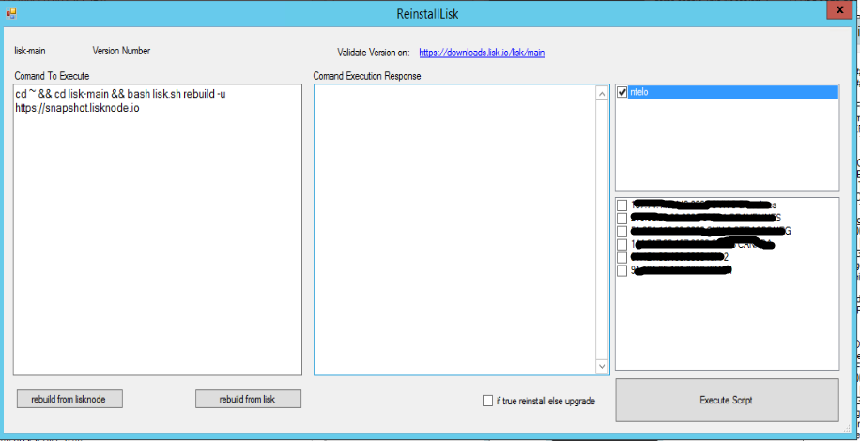

1 – **rebuild node from snapshot** in lisknode(only in mainnet) it will show script to execute and select your account and servers to execute script. After that click execute script. After execution it will show a message ok.

After that you need to enable monitor monitor again.